**Business Problem:**

One of our clients is looking to mode to either Toronto or New York. He would like to move to one of these two cities and open a new business there and has asked our help in recommending a business type and City/neighborhood.

He has given us a list of six business types he would like to open:

* Bakery
* Indian Restaurant
* Mexican Restaurant
* Italian Restaurant
* Thai Restaurant
* Hotel

**Data Required:**

We are going to start with the publicly available census data from the two cities and correlate it with geo-spatial data. This will give us the ability to visualize this data

We are going to use Four Square data to perform query for existing business types which fit this profile and first find out which city has the least business of this type. Four Sqaue data will also give is counts for these business types in each neighborhood.

Once we narrow down the business, we will use the four square data to identify areas where this kind of business is less. Using this data we will be able to recommend a business type and a geographic area to our client.

**Methodology**

Our approach is to target neighborhoods in one of the cities where our client can open a restaurant, he has provided us a list of target businesses.

In the first step we will try to identify which of these businesses has the least numbers in the city. Our basic assumption is that all businesses have the same appeal and also all the neighborhoods have comparable population. We realize that in real world this may not be true, but we make this assumption to simplify the analysis.

Once we have identified the type of business, we will then start looking for geographic areas where this business has the least quantity so that we have the minimal competition.

With this data we will recommend to our client the geographic area which he should open his business in.

Further to reduce the number of calls, we will focus in the areas of Manhattan in NY and Downtown Toronto

**Results**

Our analysis indicates that in both Manhattan and Downtown Toronto, Indian restaurants are the least in numbers, hence our recommendation is to open an Indian restaurant.

* Venue Type: " Bakery " Number in Manhattan: 76
* Venue Type: " Indian " Number in Manhattan: 33
* Venue Type: " Italian " Number in Manhattan: 134
* Venue Type: " Mexican " Number in Manhattan: 62
* Venue Type: " Thai " Number in Manhattan: 26
* Venue Type: " Hotel " Number in Manhattan: 74
* Venue Type: " Bakery " Number in Downtown Toronto: 36
* Venue Type: " Indian " Number in Downtown Toronto: 11
* Venue Type: " Italian " Number in Downtown Toronto: 40
* Venue Type: " Mexican " Number in Downtown Toronto: 14
* Venue Type: " Thai " Number in Downtown Toronto: 20
* Venue Type: " Hotel " Number in Downtown Toronto: 45

Now let’s look at the geographic restaurants in both Manhattan and Downtown Toronto. We have color coded the neighborhoods such that a red indicates that there is more than one restaurant in the neighborhood, while blue indicates that there is no restaurant in the neighborhood.

Let’s look at Manhattan first:

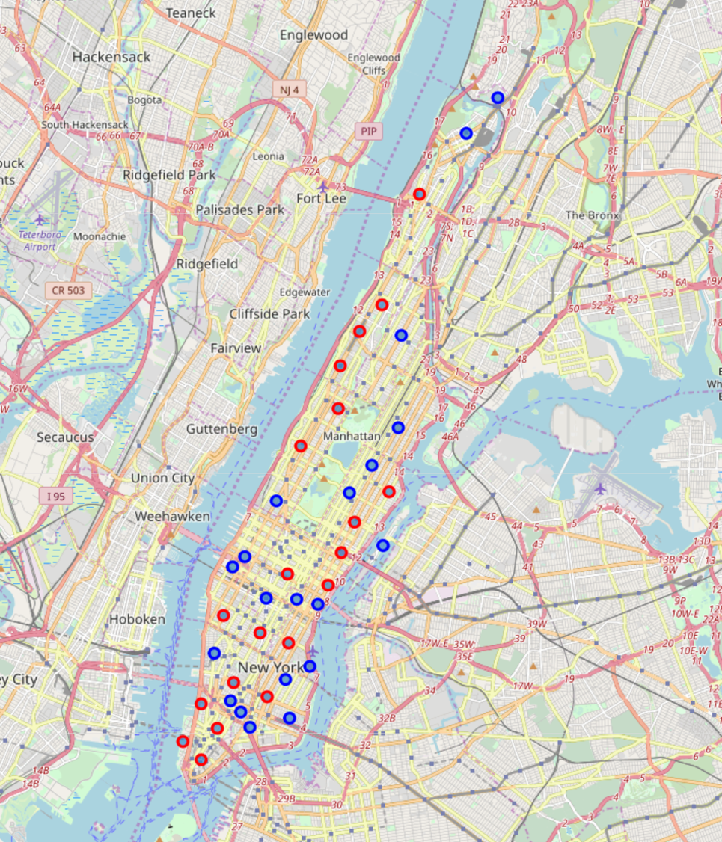

The data indicates that there is a very uniform distribution Indian restaurant ans is not easy to identify a potential geographic area.

Now let’s look at Toronto data.

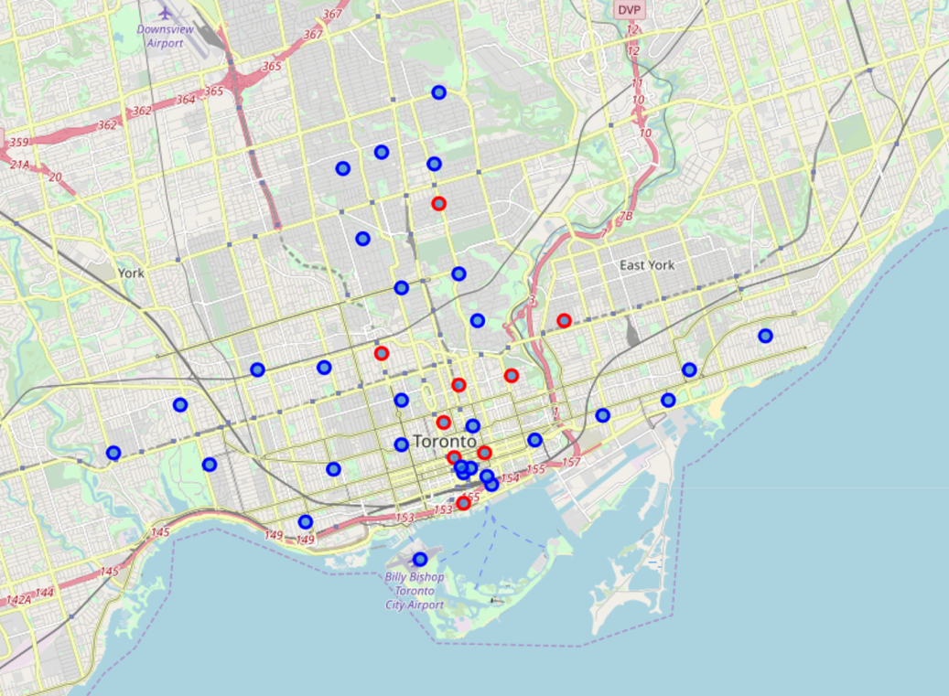



The Indian restaurants are concentrated in the middle and we see two potential areas for the business.

**Discussion**

Our analysis shows that there are two potential areas in Toronto to open Indian restaurant. These two cover multiple neighborhoods areas and these currently have no Indian restaurant. Our recommendation is to look at potential business sites in these two areas and find a venue which has the least cost of entry.

**Conclusion**

Our recommendation is to open an Indian restaurant in one of the two neighborhoods identified in the previous section.